Docker Volume mounts
Docker Volume Mount types 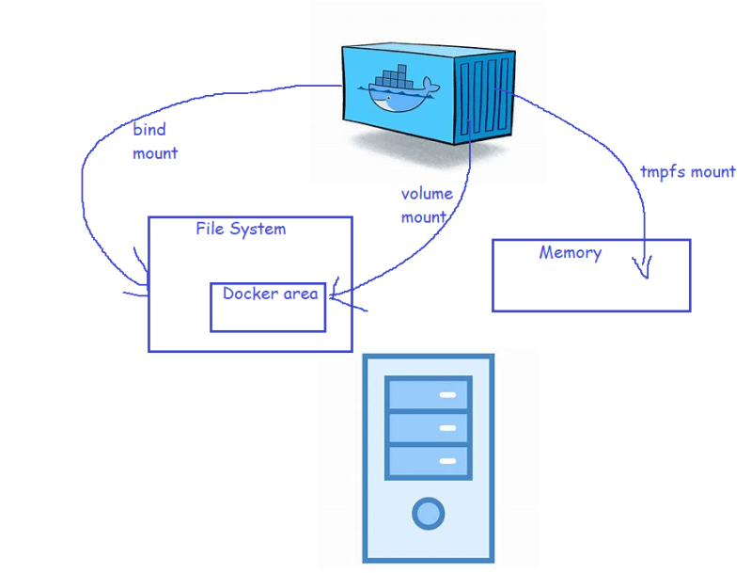
- Lets create a docker volume for the apache html folder 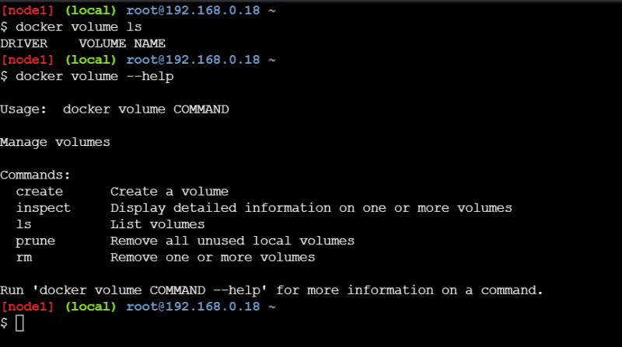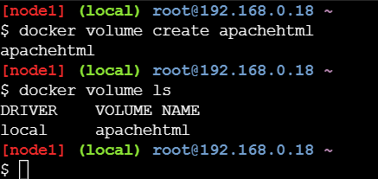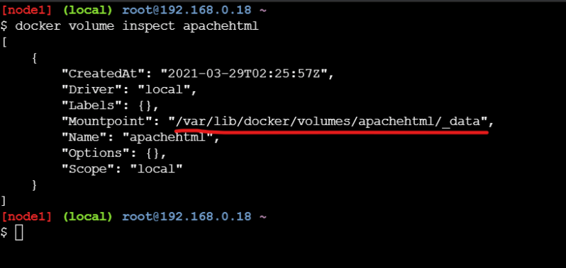
- Start the container with a volume
docker container run -d --name apache1 -P --mount "source=apachehtml,target=/var/www/html" httpd:latest
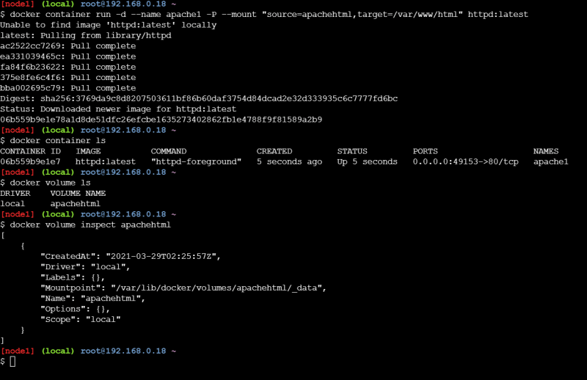
Now lets verify the mount point in the docker container
docker container inspect apache1
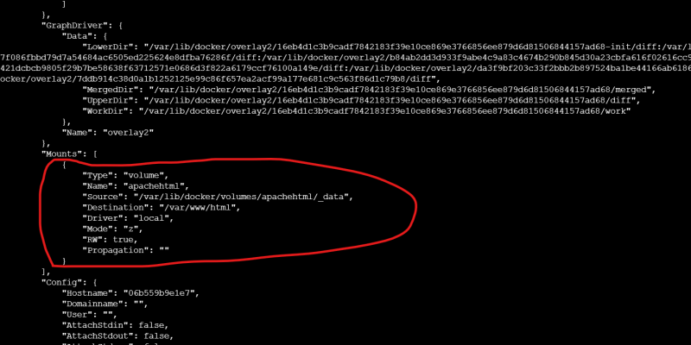
Now lets create some files in the /var/www/html folder from the container 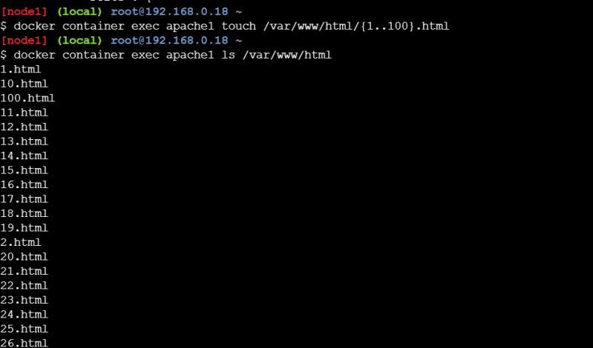
Now let’s create a new container and mount the same volume into same folder (-v)
docker container run -d --name apache2 -P -v 'apachehtml:/var/www/html' httpd:latest
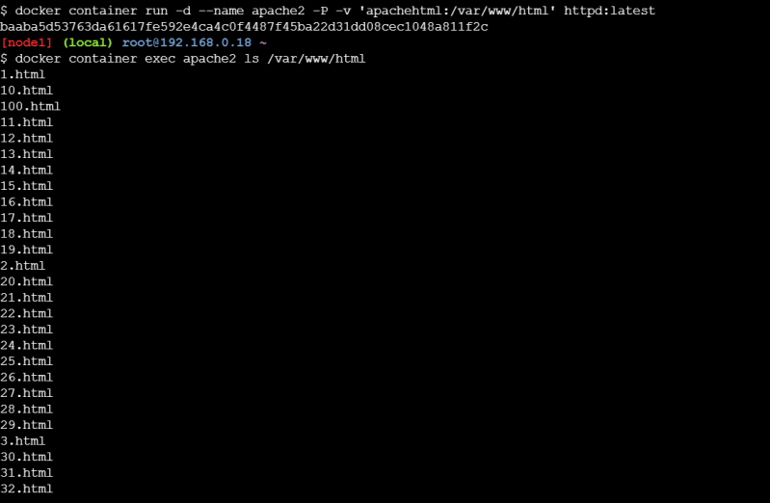
- Now lets delete all the containers
docker container rm -f $(docker container ls -a -q)
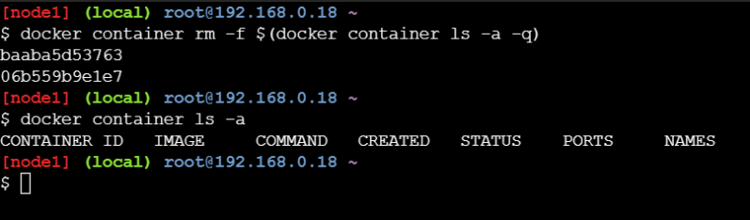
- Now lets create a new container and use the same volume mount
docker container run -d --name apache3 -P --mount "source=apachehtml,target=/var/www/html" httpd:latest
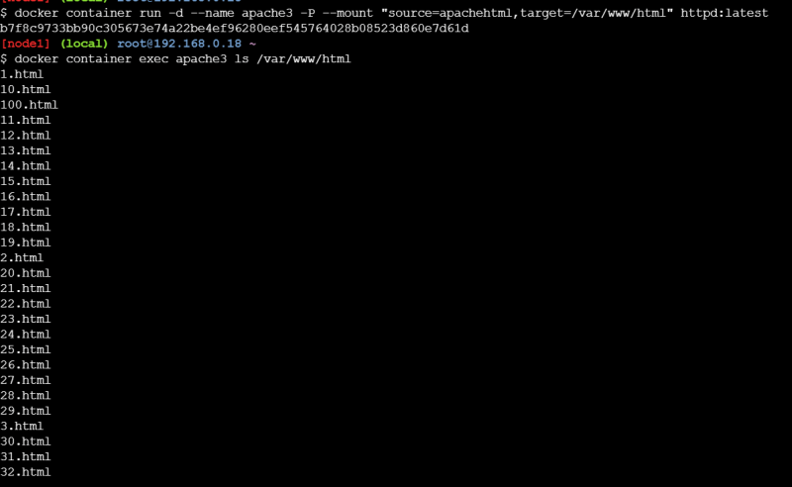
- Volume driver can help in creating volumes in the
  - nfs
  - cifs
  - cloud
- We need to install volume plugins and then use the volume driver while creating the volume
- Lets create a Postgres container with volume mounted so that we can preserve the data(https://hub.docker.com/_/postgres)
- postgres stores the data in the folder /var/lib/postgresql/data
- Lets create a postgres container 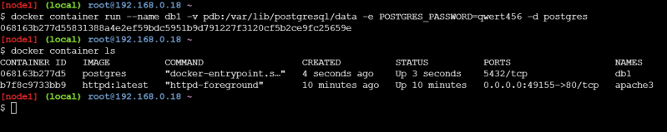
- Now lets use exec command to create some data in the database 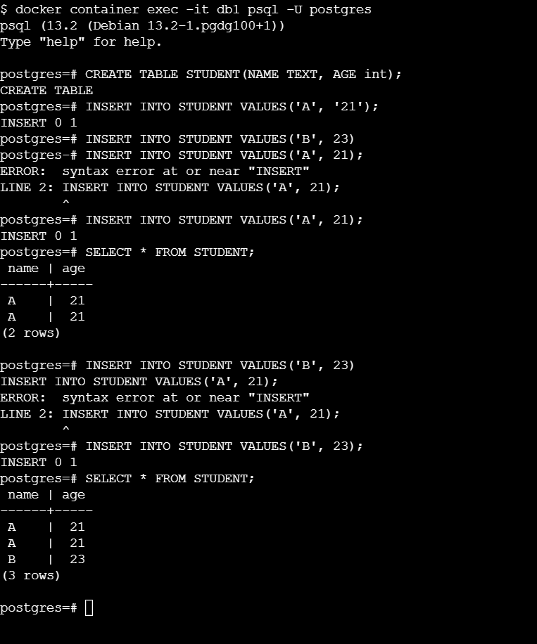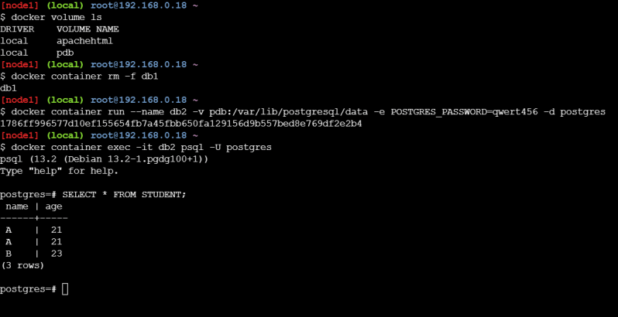
- Containers can run applications of two types
  - Stateless: These applications donot store any data locally, so we dont need volumes for them
  - Stateful: these applications store the data and this data needs to be preserved so for stateful applications we use docker volumes
- Useful docker commands
  - docker system df: This command will help in findng out the size of all docker objects in the Host 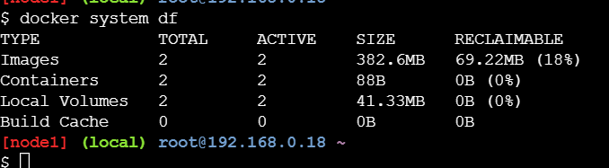
  - To get more detailed information use docker system df -v 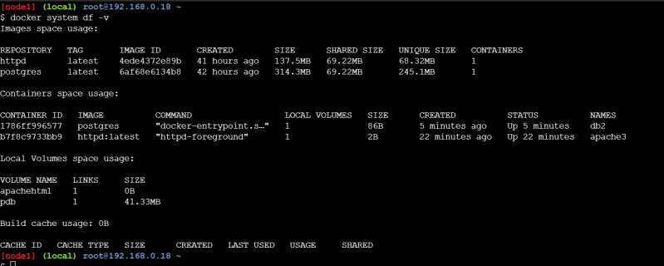
- To view the logs we can use the docker 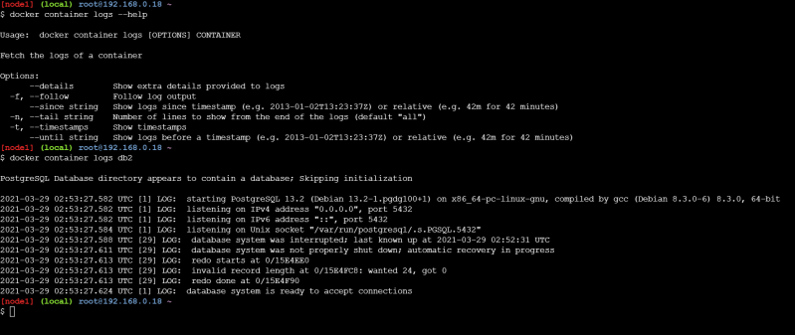
- The other approach of storing logs is create a volume for the /var/logs folder and then export the logs from the docker host to central logs.
- The other approach is to have a log client inside the container running which exports logs to centralized log server.
- For tempfs mount(Link: https://docs.docker.com/storage/tmpfs/)

